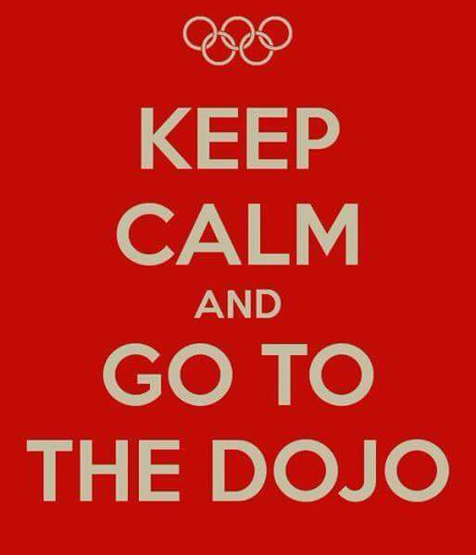

Friday March 20, 2020 6:30pm - 9:00pm.

**The Karate Studio**

3260 Holmestown RD (*2nd floor)* Myrtle Beach

Family self-defense night! Friendly fun and food all FREE

Appropriate for ages 8 and over. As a family its important to discuss not only physical protection but mental protection and self-awareness. Sensei Nelson and Sensei Lisa along with their son AJ (a junior black belt) will go through a series of self-defense techniques as well as some fun drills to promote family bonding.. Karate begins and ends with respect so we use our words first to deescalate a situation. There is no first strike in karate but self-defense is something completely different and used when necessary.

Healthy Concepts, Inc. is a 501c3 nonprofit organization whose mission is to work with the community to help children combat bullying and improve self-esteem while cultivating leadership in a safe and nurturing environment. 843-668-4225 for more information. Please feel free to also visit their website at [www.healthyconceptsmb.org](https://l.facebook.com/l.php?u=http%3A%2F%2Fwww.healthyconceptsmb.org%2F%3Ffbclid%3DIwAR1cfZqjs27Eu7sBm7Fj1kl1C_WPe9O1LSgN86u_uTINFNY4czduM5XhL80&h=AT2fiWQiogUOlaTe6-vcYMsv5LSmcbhj4gjZwUW2ulLg-_uknK-Br-lzyxeecvMIKfBIi_IGjCO6VNoKZtNZDJcMD6nzvQZmCs4LKj1Z_RokevA2XtrLpHyc25VmEz0_8dLsGMJfvqLD_lRFYw)